Unit Title: Rhythm, Community-Building and Art

Enduring (Big) Idea: Music connects individuals, who identify with a particular community and can bring comfort to all in the community. While many, if not most, visual art classrooms emphasize individual work, this unit emphasizes community-building by combining music and visual arts. Students will participate in a community-building process in the making and viewing of their artwork.
Key Concepts about the Enduring Idea:
Creating community through music and art making is the key concept for the unit of study. Creating community is important because many students aren’t often exposed to community-building activities such as this, and it gives students a sense of belonging with those around them.
- movement influenced by music
- connection of mind and body
- free flowing movement and ideas
- creating as a community
- community collaboration inspiring individual work
- positivity in collaboration

Key Concepts:
- allowing students to get messy
- using natural tools (hands) to create rather than brushes
- utilizing a technique that is seen as “childish”
- having the class create a community piece they all participated in making
- thinking about music on a more physical and mindful level
- creating as a community
- creating individually to influence a community creation
- using teamwork and positivity to reconstruct a large artwork
- problem solving when teamwork becomes challenging
- learning about artists who paint with their hands creates a sense of belonging to a community of artists
- creating individually to influence and contribute to a community creation is one way to feel a sense of belonging to a community

Essential Questions:
- How does music affect our mind?
- How does music affect our body?
- How might music create a stronger connection between our thoughts and movement?
- What are the benefits of creating a community-made piece of art vs. an individual project?
- Could allowing students to get messy motivate them to create more art/enjoy art more thoroughly?
- How does an individual’s artwork influence the communities artmaking and visa versa?
- Is the process of teamwork to recreate the original piece artwork in itself?
- What is the importance of the creative process in relation to the artistic artifact left behind?

Rationale:
Many students view their artwork as individual, and don’t even begin to consider what they could accomplish if they combined their individual skills and thoughts. Music is something that can bring a community together, and so we will practice this idea with paint.

Unit Objectives:
- Allow music to help thoughts/ideas and body movement connect and flow together
- Allow music to connect students as a creative community
- Acknowledge and understand the art making process of finger painting as an important and not “childish” practice
- Create an artwork as a community in a positive and encouraging manner
Standards:
-VA:Cr2.1.6a Demonstrate openness in trying new ideas, materials, methods, and approaches in making works of art and design
-VA:Re8.1.6a Interpret art by distinguishing between relevant and non-relevant contextual information and analyzing subject matter, characteristics of form and structure, and use of media to identify ideas and mood conveyed
-VA:Cr1.1.6a Combine concepts collaboratively to generate innovative ideas for creating art

End of Unit Assessment:
EVIDENCE: Students will combine their images back together into one banner, witnessing their art physically connected to the rest of the community’s (classroom’s) art.
RUBRIC/LEVELS and CRITERIA: Achievement will be judged based off of student effort and participation in the group activities and individual activities.
OVERVIEW OF LESSONS
1. How will you help students connect the enduring idea/theme to the students’ lives?
The students will be encouraged to think about any community art they’ve created before, if any, and how they think about/listen to certain popular songs.
2. How will you build the students’ knowledge base about the enduring idea/theme as it relates to life? Emphasis will be placed on the idea of working as a community rather than alone to create a community-made piece of art.
3. How will you build the students’ knowledge base about the enduring idea/theme as it occurs in art (e.g., media, practice, theory, art criticism, art history, aesthetics, visual culture)?
The students will gain knowledge of the media and visual culture by connecting popular music and artmaking.
4. How will you engage students with exploring, questioning, and problematizing the enduring idea/theme through artmaking?
During the activity, students will be asked to consider those around them and how/what others are creating in the group.

LESSON 1: What will students DO? What will students LEARN from this?
- Students will loosely paint on paper as a group while music plays, using any color of paint preferred/provided.
- Students will learn what it is to work as a community and to consider others’ art making processes.
LESSON 2: What will students DO? What will students LEARN from this?
- Students will cut apart community creation in even squares. They will then individually observe their piece closely to find an image in the previous painting and reproduce it.
- They will learn to make a new image with different material over the found image.
LESSON 3: What will students DO? What will students LEARN from this?
- Students will reconstruct the original community piece by stapling together their individually designed squares.
- Students will learn that in the act of reconstructing the original art piece, they are also combining their original ideas and contributing to the community in a deeper, more individual way. They will also be able to make connections as to how the community has influenced their individual art practice.

ARTMAKING PROBLEM / CONCEPTUAL STRATEGY
What conceptual strategy will help students to question, explore, or problematize the enduring idea? How will the conceptual strategy help students to question, explore or problematize the enduring idea?
A few conceptual strategies that will help students are layering and appropriation. Layering because students will layer ideas and images onto each other, making an entirely new image. Appropriation will also help because students will be using an existing image from their banner to draw a new image.
PERSONAL CONNECTIONS / ARTMAKING BOUNDARIES
What limits will you place on students' artmaking?
The only limits that will be placed on students’ artmaking will be that students will have to make sure images made are appropriate and don’t entirely cover the already painted pattern.
ARTWORKS, ARTISTS, ARTIFACTS

Artist: Iris Scott
Art Process: Finger painting
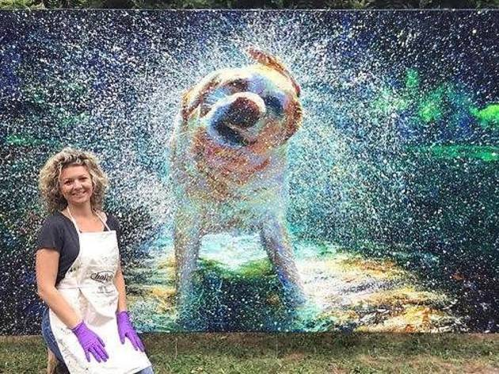
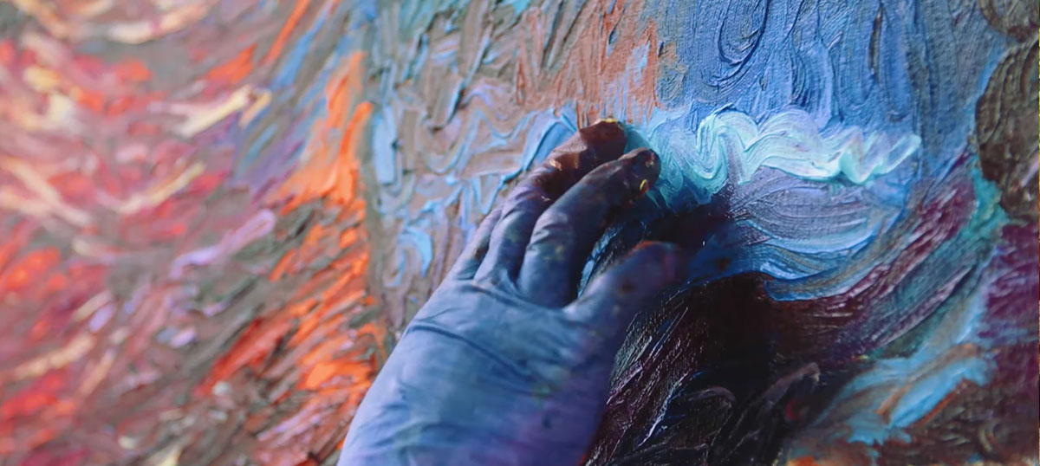

Artist: Melissa McCracken
Art Process: Synesthesia

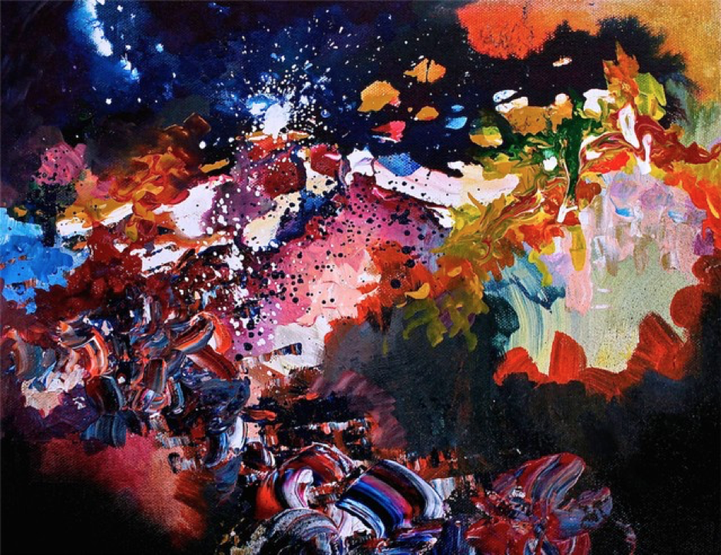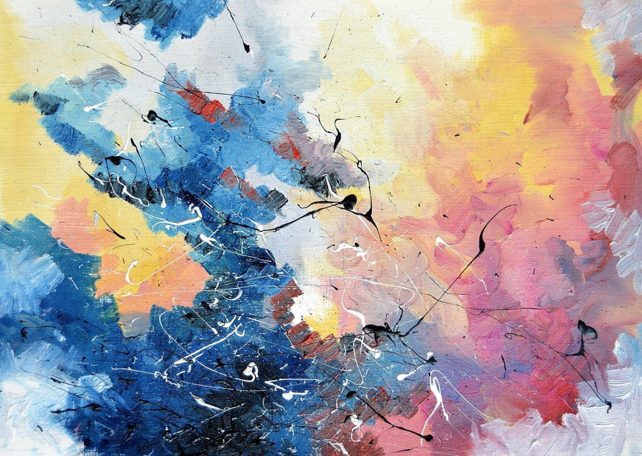

MATERIALS AND RESOURCES
What materials, resources and supplies are required to teach this lesson?
- tempera paint
- banner paper
- speakers
- pencils/pens
- staples
- scissors
- Youtube
- reference art

LACIE – LESSON 2

- UNIT TITLE: Rhythm, Community Building Art
- ENDURING IDEA/THEME: Art and music connects individuals, who identify with a particular community and can bring comfort to all in the community. While many, if not most, visual art classrooms emphasize individual work, this unit emphasizes community-building by combining rhythm and visual arts. Students will participate in a community-building process in the making and viewing of their artwork.
- LESSON NUMBER: 2
- LESSON TITLE: Community Layering
- GRADE OR CLASS: ?
- TIME ALLOTMENT: 20-25 minutes
- LESSON SUMMARY: Students will cut up the banner that the 6th grade class made in lesson 1 into even 4 x 4 squares of their choosing. Students will use the designs they see from their first painting to draw/paint a new image over the square they have chosen from lesson 1’s banner while still keeping an essence of lesson 1’s layer.
- ARTWORKS, ARTISTS and/or ARTIFACTS: Iris Scott
- KEY CONCEPTS addressed in this lesson:
- Creating art as a community
- Creating layers with an artwork
- The importance of individual influence on the community-building art project
- ESSENTIAL QUESTIONS addressed in this lesson:
- What are the benefits of creating community-building art vs. an individual art project?
- How does an individual’s artwork influence the art classroom community-building art and vice versa?
- STANDARDS
- VA:Cr2.1.6a Demonstrate openness in trying new ideas, materials, methods, and approaches in making works of art and design
- VA:Re8.1.6a Interpret art by distinguishing between relevant and non-relevant contextual information and analyzing subject matter, characteristics of form and structure, and use of media to identify ideas and mood conveyed
- VA:Cr1.1.6a Combine concepts collaboratively to generate innovative ideas for creating art
- LESSON OBJECTIVES
- Students will demonstrate making their individual marks on a piece that’s already been started
- Students will demonstrate community-building
- ASSESSMENT
- How will students and you know that they have learned what is intended in this lesson? The students will be able to produce another piece from the previous artwork done earlier in the unit while keeping and using an essence of the design made in lesson 1 in the square they choose. The demonstration of community-building will be carried out through the unit as a whole with this lesson’s product being a creation of an original painting/drawing on top of one layer that has already been completed in lesson 1 to demonstrate the influence of an individual leaving a mark on a community-building artwork that will be put together in the end of the unit.
- What objects or performances will count as evidence of student learning as stated in your objectives for this lesson? Visual evidence of development of lesson 1’s community finger painting banner by the addition of new images on top of the image that was already created from lesson 1.
- How will you measure student achievement? The evidence of completion of the square they have chosen with development of lesson 1’s painting. This completion will be determined by their participation in the lesson and when the student believes they’ve left their signature mark on their individual square of the larger project.
- How will you sequence instruction to facilitate learning? The teacher will introduce the activity through verbal instruction and students will begin the task of cutting their square from the banner and then they’ll create their own individual marks on top of first painting that was made in lesson 1.
- PREPARATION
- Teaching Resources:
- Youtube
- Student Supplies:
- Paint
- Markers
- Colored pencils
- Square of the banner paper
- Scissors

